**OBJECT ORIENTED CONCEPT & PROGRAMMING**

**(SE-201) LAB-7**

**TAQI HAIDER_CSIT_SECTION:B_ROLL#CT-22092**

**Exercise:-**

**Q1:-**

#include<iostream>

#include<cstring>

using namespace std;

const double pi=3.142;

class Circle{

    double radius;

    public:

    Circle(){radius=0.0;}

    Circle(double radius):radius(radius){}

    void set_radius(double radius){

        this->radius=radius;

    }

    double get_radius(){

        return radius;

    }

    double CalcArea(){

        return pi* radius *radius;

    }

    double CalcCircumference(){

        return 2*pi*radius;

    }

    string tostring(){

        return "Circle with Radius: "+to_string(radius);

    }

    bool equals(Circle &c){

        return this->radius==c.radius;

    }

};

class Cylinder:public Circle{

    double height;

    public:

    Cylinder(){

        height=0.0;

    }

    Cylinder(double radius,double height):Circle(radius),height(height){}

    void set_height(double height){

        this->height=height;

    }

    double get_height(){

        return height;

    }

    double CalcArea(){

        double basearea=Circle::CalcArea();

        double Lateralarea= 2*pi* get_radius()*height;

        return 2*basearea*Lateralarea;

    }

    double CalcVolume(){

        return Circle::CalcArea()*height;

    }

    string tostring(){

        return "Cylinder with Radius: "+to_string(get_radius())+" Cylinder with Height: "+to_string(height);

    }

    bool equals(Cylinder &c){

        return Circle::equals(c)&&this->height==c.height;

    }

};

int main(){

    Circle circle1(5.0);

    Circle circle2(5.0);

    Cylinder cylinder1(3.0,7.0);

    Cylinder cylinder2(7.0,3.0);

    cout<<"The String is:"<<circle1.tostring()<<endl;

    cout<<"The Circle Area is: "<<circle1.CalcArea()<<endl;

    cout<<"The Circle Circumference is: "<<circle1.CalcCircumference()<<endl;

    cout<<"The Circle is equal or not: "<<circle1.equals(circle2)<<endl;

    cout<<"The String is:"<<cylinder1.tostring()<<endl;

    cout<<"The Circle Area is: "<<cylinder1.CalcArea()<<endl;

    cout<<"The Circle Circumference is: "<<cylinder1.CalcCircumference()<<endl;

    cout<<"The Circle is equal or not: "<<cylinder1.equals(cylinder2)<<endl;

}

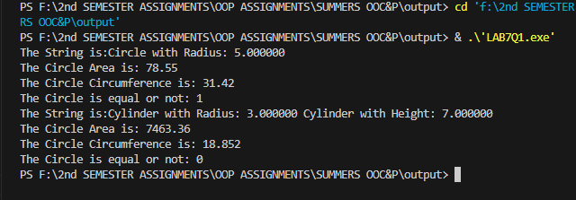

**Q2:-**

#include <iostream>

using namespace std;

class CarParts

{

protected:

    string Brand;

public:

    CarParts(string brand) : Brand(brand) {}

    string get_brand()

    {

        return Brand;

    }

    virtual void info()

    {

        cout << "The name of " << Brand << endl;

    }

};

class Doors : public CarParts

{

    string location;

public:

    Doors(string loc, string brand) : CarParts(brand), location(loc) {}

    void open()

    {

        cout << location << " door is opened." << endl;

    }

    void close()

    {

        cout << location << " door is closed." << endl;

    }

    void info() override

    {

        cout << "This is a " << get_brand() << " at " << location << endl;

    }

};

class Windows : public CarParts

{

    string location;

public:

    Windows(string loc, string brand) : CarParts(brand), location(loc) {}

    void open()

    {

        cout << location << " window is opened." << endl;

    }

    void close()

    {

        cout << location << " window is closed." << endl;

    }

    void info() override

    {

        cout << "This is a " << get_brand() << " at " << location << endl;

    }

};

class Engine : public CarParts

{

    string horsepower;

public:

    Engine(string hp, string brand) : CarParts(brand), horsepower(hp) {}

    void start()

    {

        cout << "The Engine of Horsepower " << horsepower << " is started." << endl;

    }

    void stop()

    {

        cout << "The Engine of Horsepower " << horsepower << " is stopped." << endl;

    }

    void info() override

    {

        cout << "This is a " << get_brand() << " & the hp of " << horsepower << endl;

    }

};

class Wheels : public CarParts

{

    string mirror;

public:

    Wheels(string m, string brand) : CarParts(brand), mirror(m) {}

    void rotate()

    {

        cout << "Wheels are rotated" << endl;

    }

    void setMirror(string m)

    {

        if (m == "yes")

        {

            cout << "Mirror is on" << endl;

        }

        else

        {

            cout << "Mirror is off" << endl;

        }

    }

    void info() override

    {

        cout << "This is a " << get_brand() << " & Mirror status : " << mirror << endl;

    }

};

class Car

{

    Doors frontDoor;

    Doors rearDoor;

    Windows frontWindow;

    Windows rearWindow;

    Engine engine;

    Wheels wheels;

public:

    Car(string doorLocation, string windowLocation, string engineHP, string wheelMirror)

        : frontDoor(doorLocation, "BMW"),

          rearDoor(doorLocation, "BMW"),

          frontWindow(windowLocation, "Mercedes"),

          rearWindow(windowLocation, "Mercedes"),

          engine(engineHP, "Audi"),

          wheels(wheelMirror, "Civic") {}

    void start()

    {

        engine.start();

    }

    void stop()

    {

        engine.stop();

    }

    void openFrontDoor()

    {

        frontDoor.open();

    }

    void closeFrontDoor()

    {

        frontDoor.close();

    }

    void openRearDoor()

    {

        rearDoor.open();

    }

    void closeRearDoor()

    {

        rearDoor.close();

    }

    void openFrontWindow()

    {

        frontWindow.open();

    }

    void closeFrontWindow()

    {

        frontWindow.close();

    }

    void openRearWindow()

    {

        rearWindow.open();

    }

    void closeRearWindow()

    {

        rearWindow.close();

    }

    void rotateWheels()

    {

        wheels.rotate();

    }

    void setWheelMirror(string m)

    {

        wheels.setMirror(m);

    }

    void carInfo()

    {

        cout << "Car Brand: " << wheels.get_brand() << endl;

        cout << "Car Parts Information:" << endl;

        frontDoor.info();

        rearDoor.info();

        frontWindow.info();

        rearWindow.info();

        engine.info();

        wheels.info();

    }

};

int main()

{

    Car myCar("Front", "Front", "300hp", "yes");

    myCar.carInfo();

    myCar.start();

    myCar.openFrontDoor();

    myCar.openFrontWindow();

    myCar.rotateWheels();

    myCar.stop();

    myCar.closeFrontDoor();

    myCar.closeFrontWindow();

    return 0;

}

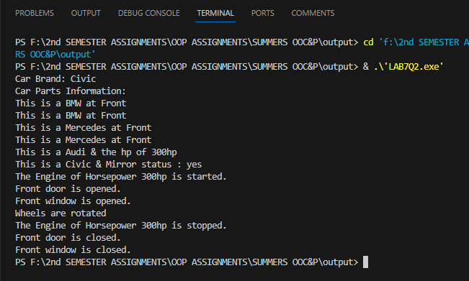

**Q3 :-**

#include <iostream>

using namespace std;

class BOX

{

    double width, length, height;

public:

    BOX() : width(0.0), length(0.0), height(0.0) {}

    BOX(double w, double l, double h) : width(w), length(l), height(h) {}

    void showdata()

    {

        cout << "The width of the BOX: " << width << endl;

        cout << "The length of the BOX: " << length << endl;

        cout << "The height of the BOX: " << height << endl;

    }

    void calcVolume()

    {

        cout << "The volume is :" << width * length * height << endl;

    }

    BOX operator+(BOX &b)

    {

        return BOX(width + b.width, length + b.length, height + b.height);

    }

    BOX operator-(BOX &b)

    {

        return BOX(width - b.width, length - b.length, height - b.height);

    }

    BOX operator*(double scalar)

    {

        return BOX(width * scalar, length * scalar, height * scalar);

    }

    BOX operator/(double scalar) const

    {

        if (scalar == 0.0)

        {

            std::cerr << "Error: Division by zero." << endl;

            return *this;

        }

        return BOX(width / scalar, length / scalar, height / scalar );

    }

};

int main()

{

    BOX box1(2.0, 3.0, 4.0);

    BOX box2(1.0, 1.5, 2.0);

    // Display data of box1 and box2

    cout << "Box1 data: ";

    box1.showdata();

    cout << "Box2 data: ";

    box2.showdata();

    // Perform operations on boxes

    BOX additionResult = box1 + box2;

    BOX subtractionResult = box1 - box2;

    BOX multiplicationResult = box1 * 2.0;

    BOX divisionResult = box1 / 2.0;

    // Display results

    cout << "Addition Result: " << endl;

    additionResult.showdata();

    cout << "Subtraction Result: " << endl;

    subtractionResult.showdata();

    cout << "Multiplication Result: " << endl;

    multiplicationResult.showdata();

    cout << "Division Result: " << endl;

    divisionResult.showdata();

}

